

A Project Report on,
To analyze plagiarism patterns in literature review sections and distinguish direct copying from technical paraphrasing using text analysis and contextual review.
By,
Nirmitee Chavan
(SRN: 31242285)
Project No : 2
Guided By
Dr. Anupriya Kamble

Course Name: Research Methedology
For the Programme
B.Sc. - COMPUTER SCIENCE
Third Year
In the Year
2026-27

Pursued in
Department of Computer Science
Faculty of Science & Technology
Vishwakarma University, Pune

CERTIFICATE
This is to certify that the work incorporated in the Project entitled “To analyze plagiarism patterns in literature review sections and distinguish direct copying from technical paraphrasing using text analysis and contextual review.” submitted to Vishwakarma University, Pune by Nilakshi Shukla for the completion of the course Research Methedology was carried out by him/her under my supervision in the Department of Computer Science, Faculty of Science and Technology, Vishwakarma University, Pune, Maharashtra, India. This work was not previously submitted by him/her to this or any other University for the award of any Degree, Diploma, Associateship or any other similar title.

Place: Pune Dr. Anupriya Kamble
Date: Course Coordinator

DECLARATION
I hereby declare that the present research work in the form of project report
entitled “To analyze plagiarism patterns in literature review sections and distinguish direct copying from technical paraphrasing using text analysis and contextual review”.., is an original work carried out by me under the guidance of Dr.Anupriya Kamble, Assistant Professor, Department of Computer Science, Faculty of Science and Technology, Vishwakarma University, Pune, Maharashtra, India for the completion of the course name Research Methedology
I further declare that to the best of my knowledge the project work does not
contain any part of any work, which has been submitted for the award of any
Degree, either in this University or any other University / Deemed University
without proper citation.

I further declare that the material referred from other sources has been
duly acknowledged in the project report.

Place: Pune
Date:

ABSTRACT

Literature review sections play an important role in academic research by summarizing previous studies, comparing existing approaches, identifying research gaps, and establishing the foundation for new investigations. However, inappropriate source use in literature reviews can occur in different forms, including direct copying, near-verbatim reuse, technical paraphrasing, patchwriting, and the combination of content from multiple sources without adequate attribution. A similarity score alone cannot establish plagiarism because properly cited quotations, common technical terminology, and standard academic phrases may also produce textual overlap.
This project proposes a structured taxonomy and a Python-supported research workflow for analyzing plagiarism-related textual patterns in literature review sections of rejected conference manuscripts. The proposed approach includes document preparation, candidate-source comparison, text feature extraction, citation-context analysis, and human annotation. It aims to distinguish direct copying from technical paraphrasing by considering lexical similarity, sentence structure, semantic similarity, and citation placement.
The research is situated in the area of Plagiarism & Academic Integrity, with the proposed research context referring to the Journal of Information Ethics (Scopus Q2) and ICSSR Grant. The study will examine category consistency and the distribution of observed patterns after an authorized corpus has been collected and annotated. As data collection and annotation are pending, this report presents the proposed research plan and does not claim completed empirical results.
Keywords: Plagiarism Detection, Academic Integrity, Literature Review, Direct Copying, Technical Paraphrasing, Patchwriting, Text Similarity, Python.

INDEX
Sr. No. | Content | Pg. No.
1. | Introduction | 6
 | 1.1 Objective | 6
 | 1.2 Novel Idea | 6
 | 1.3 Significance | 6
 | 1.4 Specifications | 6
2. | Literature Survey  2.1 Plagiarism Detection and Text Similarity  2.2 Technical Paraphrasing and Patchwriting  2.3 Citation Context and Human Assessment  2.4 Research Gap | 7
3. | Methodology  3.1 Research Design  3.2 Corpus Selection and Data Collection  3.3 Proposed Taxonomy and Annotation  3.4 Text Processing and Feature Analysis  3.5 Evaluation Measures | 8
4. | Implementation  4.1 System Architecture  4.2 Software and Tools  4.3 Workflow and Modules  4.4 Testing and Evaluation Plan | 9
5. | Conclusion and Future Scope  5.1 Conclusion  5.2 Future Scope  5.3 Result | 10

1. INTRODUCTION
Literature reviews are an essential component of academic research. They organize previous findings, compare research methods, identify limitations, and establish the foundation for new research questions. A well-written literature review demonstrates the researcher’s understanding of existing knowledge and provides a clear justification for the proposed study.
The quality of a literature review depends on accurate synthesis, appropriate source use, and clear attribution. However, inappropriate source use may appear in several forms, including direct copying, near-verbatim reuse, close paraphrasing, patchwriting, and unacknowledged reuse of ideas. These patterns can be difficult to identify because academic writing often contains common technical terms, conventional phrases, and standard expressions.
The research topic, “Analyzing Plagiarism Patterns in Literature Review Sections: Direct Copying vs. Technical Paraphrasing,” focuses on distinguishing different forms of textual overlap. It examines the wording and structure of passages, their relationship to candidate source documents, and the presence and placement of citations.
The proposed research aims to develop a structured taxonomy and a Python-supported workflow for analyzing these patterns. The system is intended to support academic-integrity research and human review. It will not automatically determine whether a researcher has committed misconduct because such decisions require contextual assessment.

1.1 OBJECTIVE
The main objective of this research is to classify source-use patterns in literature review sections and examine the distinction between direct copying and technical paraphrasing.
The specific objectives are:
- To identify plagiarism-related textual patterns in an authorized corpus of literature review passages.
- To develop a structured taxonomy covering direct copying, near-verbatim reuse, technical paraphrasing, patchwriting, multi-source blending, and legitimate source use.
- To examine citation presence and context alongside lexical and semantic indicators.
- To develop a Python-supported workflow for document processing, candidate-source comparison, annotation, and visualization.
- To evaluate annotation consistency using suitable agreement measures.
- To report the distribution of observed patterns only after corpus collection and analysis.

1.2 NOVEL IDEA
The proposed idea is to analyze plagiarism-related source use through contextual categories rather than relying only on a single similarity percentage.
The approach combines textual overlap indicators with sentence structure, semantic evidence, citation context, and human annotation. It distinguishes direct copying from technical paraphrasing while also considering patchwriting, multi-source blending, and appropriate source use.
The proposed taxonomy will include legitimate quotations and common technical terminology as comparison categories. This is important because textual similarity does not always indicate plagiarism. The novelty of the proposed approach will be assessed through the completed literature review and empirical evaluation.

1.3 SIGNIFICANCE
This research may contribute to academic integrity education and improve the transparency of manuscript review.
A structured taxonomy can help researchers and reviewers distinguish verbatim copying from close paraphrasing and acceptable source use. It may also support the development of clearer annotation guidelines and more consistent review practices.
The proposed system is designed as a research-support tool. Its similarity indicators should not be treated as proof of plagiarism. Similarly, the rejection of a manuscript does not establish that plagiarism was the reason for rejection.
The project may also provide a foundation for future research on automated text analysis, academic writing support, and responsible use of language-processing technologies.

1.4 SPECIFICATIONS
The proposed software specifications are:
- Programming Language: Python
- Document Processing: PDF and text extraction
- Text Preprocessing: Cleaning, normalization, and sentence segmentation
- Text Analysis: Lexical overlap, n-gram matching, structural indicators, and optional semantic similarity
- Data Management: CSV files or a database for structured annotation records
- Visualization: Charts for category counts, percentages, and annotation agreement
- Interface: Research dashboard or web-based annotation interface
The hardware requirements include a standard laptop or desktop computer with sufficient memory and storage to process the authorized document corpus. Exact requirements will depend on the size of the dataset and whether local semantic models are used.

2. LITERATURE REVIEW
Research on plagiarism detection has explored exact text matching, source retrieval, paraphrase identification, semantic comparison, and academic-integrity practices. Existing systems can identify candidate textual overlaps, but the interpretation of those overlaps remains an important challenge.
A systematic literature review by Foltýnek, Meuschke, and Gipp discusses the scope and limitations of plagiarism detection research. The broader literature indicates that automated systems can assist in locating suspicious passages, while contextual assessment is required to determine whether a passage is appropriately quoted, cited, or independently synthesized.
The present research focuses on literature review sections and proposes a structured analysis of direct copying, technical paraphrasing, and related source-use patterns.

2.1 PLAGIARISM DETECTION AND TEXT SIMILARITY
Lexical matching methods identify shared words, phrases, or sequences between documents. These methods are useful for detecting verbatim and near-verbatim reuse.
However, text similarity measures can be affected by common phrases, technical terminology, formatting, and reference sections. A high similarity score may include legitimate quotations or properly cited material. Conversely, a low similarity score may not reveal the reuse of ideas or extensive paraphrasing.
Therefore, similarity scores should be treated as indicators for further review rather than final evidence of plagiarism. The proposed research will combine lexical indicators with citation context and human annotation.

2.2 TECHNICAL PARAPHRASING AND PATCHWRITING
Paraphrasing involves expressing a source idea in a new form while preserving its meaning and acknowledging the source. Technical paraphrasing may involve changing selected words while retaining the original sentence structure, sequence, or distinctive phrasing.
Patchwriting refers to writing that remains closely dependent on source language despite limited substitutions or grammatical changes. It may occur when a writer attempts to paraphrase but does not sufficiently transform the original wording or structure.
These patterns can be difficult to classify using lexical comparison alone. A structured annotation guide is therefore required to distinguish direct copying, close paraphrasing, patchwriting, and acceptable source use.

2.3 CITATION CONTEXT AND HUMAN ASSESSMENT
Citation presence and placement provide important evidence about attribution. However, the presence of a citation alone does not establish that a passage has been adequately paraphrased.
Reviewers need to examine whether the citation is clearly connected to the reused material and whether quotation marks or other attribution signals are required. Human annotators can consider context that automated models may miss.
Nevertheless, annotator judgments may differ. Training, independent labeling, and adjudication can help improve the consistency and reproducibility of the analysis.

2.4 RESEARCH GAP
The proposed study addresses the need for a transparent taxonomy focused specifically on literature review sections and the distinction between direct copying and technical paraphrasing.
The study will examine the relationship between textual features and contextual labels and will report annotation reliability. The research gap will be refined after a complete literature search and verification of the relevant source publications.

3. METHODOLOGY

3.1 RESEARCH DESIGN
The project follows a planned empirical, mixed-method approach.
Quantitative analysis will summarize the frequency and distribution of annotated categories and compare selected textual features. Qualitative analysis will examine ambiguous passages, citation context, and disagreements between annotators.
The final research design will depend on corpus access, sampling requirements, and institutional ethics guidelines.

3.2 CORPUS SELECTION AND DATA COLLECTION
The proposed corpus comprises literature review sections from rejected conference manuscripts for which access and research use are authorized.
The final report should specify:
- The source conference or publication
- The sampling period
- Inclusion and exclusion criteria
- The number of manuscripts collected
- The number of literature review passages analyzed
- The method used to identify candidate source documents
Rejection status will be treated only as a sampling characteristic. It will not be interpreted as evidence of plagiarism or as proof that plagiarism caused a manuscript’s rejection.
Where candidate source documents cannot be verified, the passage will be marked as source-unverified. Manuscript identities and confidential reviewer material must be protected according to applicable institutional requirements.

3.3 PROPOSED TAXONOMY AND ANNOTATION
The proposed taxonomy includes the following categories:
1. Direct Copying
Text reproduced from a source without adequate quotation or attribution.
2. Near-Verbatim Reuse
Source wording retained with only minor edits, substitutions, or formatting changes.
3. Technical Paraphrasing / Close Paraphrase
Surface wording is changed, but the distinctive structure, sequence, or phrasing remains close to the source.
4. Patchwriting
Limited rewriting leaves the passage strongly dependent on the source language.
5. Multi-Source Blending
Material from multiple sources is combined without clear synthesis or adequate attribution.
6. Unattributed Idea Reuse
Distinctive ideas from a source are used without suitable acknowledgement, even when the wording is substantially changed.
7. Properly Attributed Quotation or Paraphrase
A comparison category representing appropriate source use.
8. Common Phrase or Technical Terminology
Textual overlap caused by conventional wording or standard technical terms.
At least two annotators should independently label an agreed subset or the full corpus. The annotation guide should define decision rules and include examples. Disagreements should be discussed or adjudicated by a third reviewer, and all changes to the annotation rules should be documented.

3.4 TEXT PROCESSING AND FEATURE ANALYSIS
The proposed processing pipeline includes:
- Document extraction
- Text cleaning and normalization
- Paragraph and sentence segmentation
- Candidate-source matching
- Text feature extraction
- Citation-context review
- Human annotation
- Data storage and reporting
The features may include exact phrase overlap, n-gram overlap, lexical similarity, edit distance, sentence structure, semantic similarity, and citation markers.
The software tools and model versions used during analysis will be documented to support reproducibility.

3.5 EVALUATION MEASURES
Inter-annotator agreement may be measured using Cohen’s kappa when two annotators are involved. Krippendorff’s alpha may be used where appropriate for the number of annotators and data characteristics.
Descriptive analysis will report the number and percentage of passages in each category.
Precision, recall, and F1-score should be reported only if an automated classifier is evaluated against a clearly defined human-annotated reference dataset.
The evaluation will also document extraction errors, source-verification limitations, and disagreements in the annotation process.

4. IMPLEMENTATION

4.1 SYSTEM ARCHITECTURE
The proposed system architecture consists of the following modules:
Document Input Module:
Accepts authorized manuscript and source documents.
Text Extraction and Preprocessing Module:
Extracts text, removes unnecessary formatting, and preserves page and paragraph references.
Candidate-Source Matching Module:
Identifies possible source passages using exact and lexical matching.
Feature Analysis Module:
Computes textual and contextual features such as lexical overlap, structural similarity, and citation markers.
Human Annotation Module:
Displays the manuscript passage and candidate source passage to the annotator for classification.
Reporting Module:
Generates category summaries, descriptive statistics, and visualizations.
Each analyzed passage should retain a manuscript identifier, location, candidate source, extracted features, annotation label, annotator confidence, and adjudication status.

4.2 SOFTWARE AND TOOLS
Python is proposed as the primary programming language.
The following tools may be used:
- PyMuPDF or pdfplumber: PDF text extraction
- Regular Expressions: Text cleaning and normalization
- Sentence Segmentation Tools: Sentence-level processing
- scikit-learn: Lexical feature extraction and similarity calculations
- Pandas: Dataset management and analysis
- Matplotlib: Data visualization
- Streamlit or a Web Framework: Optional annotation interface
The final tool selection will be documented during implementation.

4.3 WORKFLOW AND MODULES
The proposed workflow is:
- Import authorized manuscripts and source documents.
- Extract and normalize text while preserving page and paragraph references.
- Retrieve candidate source passages using exact and lexical matching.
- Compute selected textual and contextual features.
- Display manuscript and source passages for human annotation.
- Store annotation labels and notes in a structured dataset.
- Review disagreements and finalize annotations.
- Generate descriptive summaries and charts after annotation is complete.

4.4 TESTING AND EVALUATION PLAN
Pilot testing will be conducted to examine text extraction errors, source matching, and the clarity of the taxonomy.
The pilot results will be used to revise the annotation guide and improve the workflow. The final evaluation will report the actual corpus size, annotation agreement, category distribution, and study limitations.
No measured results are claimed in this report because corpus collection and annotation are pending.

5. CONCLUSION AND FUTURE SCOPE

5.1 CONCLUSION
This project proposes a structured study of plagiarism-related source-use patterns in literature review sections, focusing on direct copying versus technical paraphrasing.
The report outlines a taxonomy and a Python-supported workflow combining text comparison, citation-context review, and human annotation. The proposed approach is intended to support academic-integrity research and transparent manuscript review rather than automate misconduct judgments.
The study may provide a useful foundation for understanding the differences between verbatim reuse, technical paraphrasing, patchwriting, and appropriate source use. Empirical conclusions will be added after the authorized corpus has been collected, annotated, and evaluated.

5.2 FUTURE SCOPE
The project can be extended in the following ways:
- Collect and annotate a larger authorized corpus across multiple conferences or academic disciplines.
- Refine the taxonomy through pilot studies and expert review.
- Evaluate lexical and semantic features against human annotation labels.
- Develop a secure web interface with role-based access and audit trails, subject to privacy and ethics approval.
- Compare different corpus groups only where the sampling design supports fair interpretation.
- Publish an anonymized annotation guide or derived dataset where permissions allow.
- Explore multilingual plagiarism patterns and cross-language paraphrasing.
- Investigate the use of explainable NLP techniques to make text-analysis results easier to interpret.
5.3 RESULT




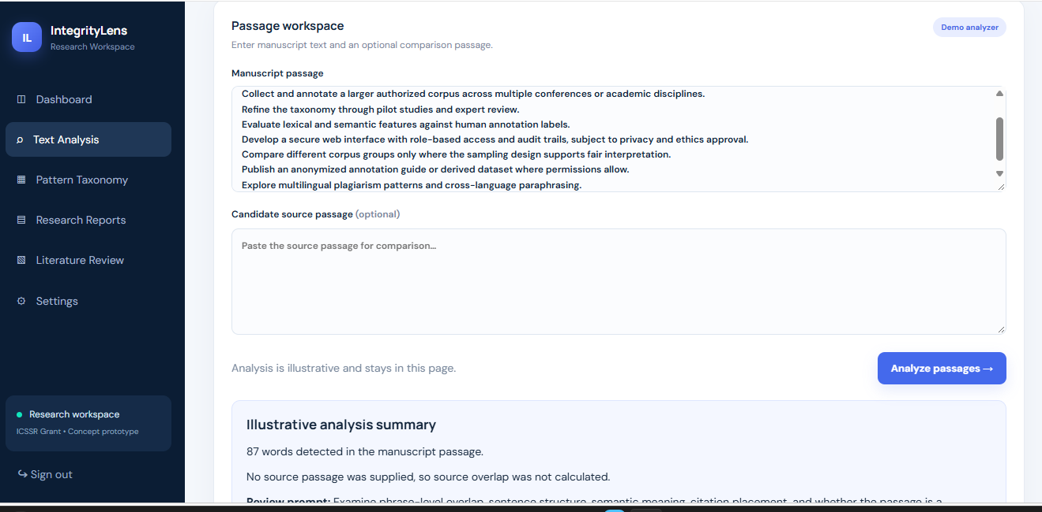

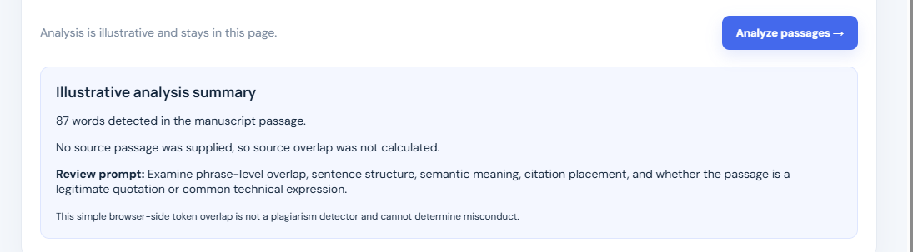

REFERENCES
[1] T. Foltýnek, N. Meuschke, and G. Gipp, “Academic Plagiarism Detection: A Systematic Literature Review,” ACM Computing Surveys, 2020. Verify volume, issue, article number, and DOI before final submission.
[2] D. Pecorari, “Good and Original: Plagiarism and Patchwriting in Academic Second-Language Writing,” Journal of Second Language Writing, vol. 12, no. 4, pp. 317–345, 2003.
[3] P. M. Maurer, F. Kappe, and B. Zaka, “Plagiarism—A Survey,” Journal of Universal Computer Science, vol. 12, no. 8, pp. 1050–1084, 2006.
[4] M. Roig, “Avoiding Plagiarism, Self-Plagiarism, and Other Questionable Writing Practices: A Guide to Ethical Writing,” Office of Research Integrity. Verify the edition and publication details.

